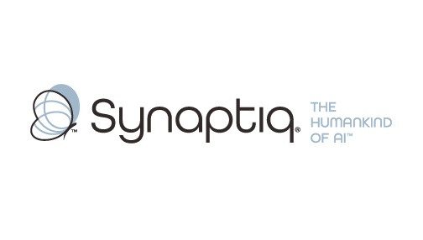
______________________________________________________________________
 | Stephen Sklarew  CEO & Co-Founder, Synaptiq  AI Strategy & Workforce Transformation | "The Humankind of AI"

Overview
Stephen Sklarew is a seasoned executive with over 30 years of experience driving organizational transformation and AI strategy across global enterprises. As CEO of Synaptiq, he specializes in translating analytics capabilities into scalable frameworks and actionable business outcomes through the proprietary AIQ® methodology. His expertise spans cross-functional alignment, workforce upskilling, and rapid capability assessment—particularly valuable for fast-moving initiatives requiring compressed timelines. Stephen has guided organizations through complex transformation journeys, emphasizing the human element of technological change while building solutions that scale across diverse markets and operational structures.
Background & Expertise
Stephen Sklarew is a seasoned business transformation executive with over 30 years of experience helping global enterprises navigate complex organizational change and AI strategy implementation. His expertise encompasses strategy development, cross-functional alignment, and workforce transformation—critical capabilities for organizations executing ambitious, fast-moving initiatives across multiple markets and stakeholder groups.
As CEO and cofounder of Synaptiq, an AI strategy and solutions firm founded in 2015, Stephen has developed a reputation for translating technical capabilities into scalable business frameworks. Under his leadership, Synaptiq created the proprietary AIQ® methodology, a comprehensive diagnostic and implementation framework that assesses organizational readiness across four critical dimensions: foundational capabilities, product lifecycle integration, data infrastructure, and AI/ML maturity. This approach has proven particularly valuable for enterprises seeking to move rapidly from assessment to execution.
Throughout his career, Stephen has held senior positions at companies like Sage Software, CEB (now Gartner), and Ernst & Young LLP, where he gained deep experience in organizational design, capability development, and cross-functional program management. His entrepreneurial background includes cofounding CircleBack (now SalesIntel) in 2008, where he led the development of a SaaS platform utilizing big data and machine learning—providing firsthand experience in scaling technology solutions across diverse market segments.
Stephen's work spans multiple industry sectors including technology, healthcare, financial services, and construction, giving him unique insight into the challenges of implementing standardized frameworks while accommodating market-specific requirements. He is particularly skilled at designing pilot programs that can scale globally while maintaining local relevance—a critical capability for multinational organizations operating across diverse regulatory and cultural environments.
As a thought leader in AI and organizational transformation, Stephen frequently shares insights on the human elements of technological change, emphasizing that successful transformation requires both technical excellence and cultural alignment. His philosophy aligns with the belief that technology should amplify human potential rather than replace it—a perspective that resonates with organizations focused on workforce development and sustainable growth. Stephen holds a BS in Biology from Virginia Tech.
Relevant Experience
- AI Strategy & Capability Assessment: Developed and deployed the AIQ® assessment framework to evaluate organizational AI readiness across foundational capabilities, data infrastructure, and technical maturity. Proven ability to rapidly diagnose current-state capabilities and translate findings into actionable roadmaps.
- Cross-Functional Framework Design: Led multiple enterprise initiatives requiring alignment across diverse stakeholder groups including technology, operations, and commercial teams. Specialized in creating scalable frameworks that work across different organizational structures and market requirements.
- Rapid Pilot Development & Scaling: Designed and executed pilot programs that move quickly from assessment to implementation, with built-in scalability for global deployment. Experience includes compressed timeline delivery and iterative framework refinement based on early results.
- Global Enterprise Transformation: Guided large, multinational organizations through complex transformation initiatives spanning multiple markets and business units. Deep understanding of the challenges in standardizing approaches while accommodating local market variations and regulatory requirements.
- Analytics Strategy & Optimization: Extensive experience in analytics lifecycle management and optimization readiness assessment. Led initiatives to evaluate existing measurement approaches and identify optimization levers that drive measurable business impact.
- Organizational Change & Upskilling: Championed workforce transformation initiatives that emphasize the human element of technological change. Proven track record in designing and implementing organizational changes that build internal capabilities while driving adoption of new frameworks and methodologies.

